he four Euler parameters
(elements of the quaternion).
They provide a redundant, nonsingular attitude
description and are well suited to describe arbitrary, large rotations. The
Euler parameter vector /J is defined in terms of the principal rotation
elements as
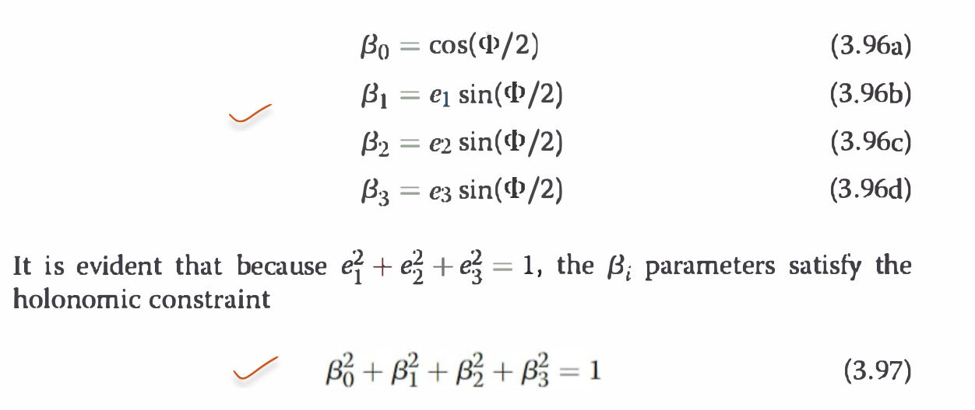
Note that this constraint geometrically describes a four-dimensional unit
sphere. Any rotation described through the Euler parameters has a trajectory
on the surface of this constraint sphere. Given a certain attitude, there are
actually two sets of Euler parameters that will describe the same orientation.
This is due to the non-uniqueness of the principal rotation elements themselves.
Switching between the sets (e, <I>) and (-e, -<I>) will yield the same
Euler parameter vector /J. However, if the second principal rotation angle
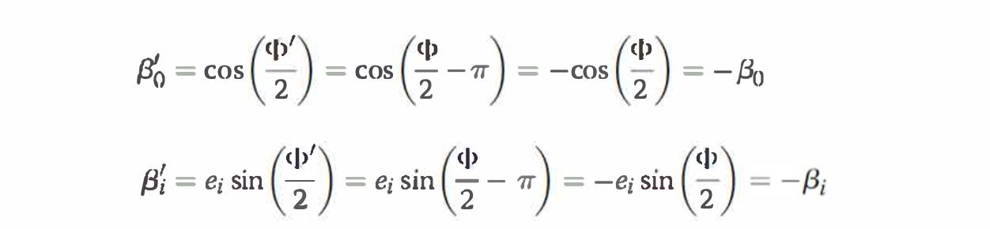
Therefore, the vector {J' = -fJ describes the same orientation as the vector
/J. This results in the following interesting observation. Because any point
on the unit constraint sphere surface represents a specific orientation, the
anti-pole to that point represents the exact same orientation. T'he difference
between the two attitude descriptions is that one specifies the orientation
through the shortest single axis rotation, the other through the longest.
From Eq. (3.96a) it is clear that in order to choose the Euler parameter
vector corresponding to the shortest rotation (i.e., l<PI < 180 deg), the coordinate
{30 must be chosen to be nonnegative.
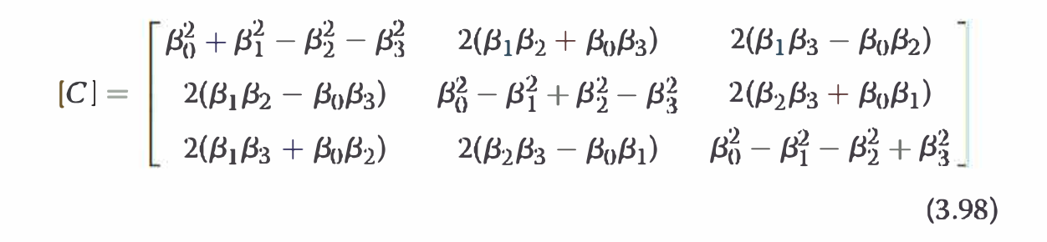

The fact that /3 and -/3 produce the same direction cosine matrix [ C] can be
easily verified in Eq. (3.98). All Euler parameters appear in quadratic product
pairs, thus changing the signs of all /3i components has no effect on the
resulting [ C] matrix. It is evident that the most general angular motion of
a reference frame generates two arcs on the four-dimensional unit sphere
[the geodesic arcs generated by fJ(t) and -/J(t)]. This elegant description is
universally nonsingular and is unique to within the sign + fJ(t). The
inverse transformations from [ C] to the

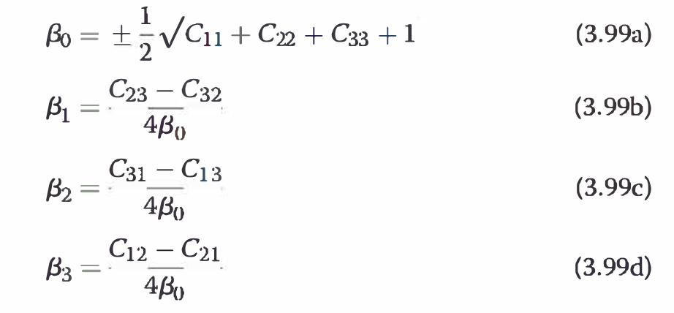
one restricts the
corresponding principal rotation angle <I> to be less than or equal to 180 deg.
From a practical point of view this non-uniqueness does not pose any difficulties.
Initially one simply picks an initial condition on one Euler parameter
trajectory and then remains with it either through solving an associated kinematic
differential, developed next, or by using elementary continuity logic.
Clearly Eq. (3.99) has a 0/0 type mathematical singularity whenever
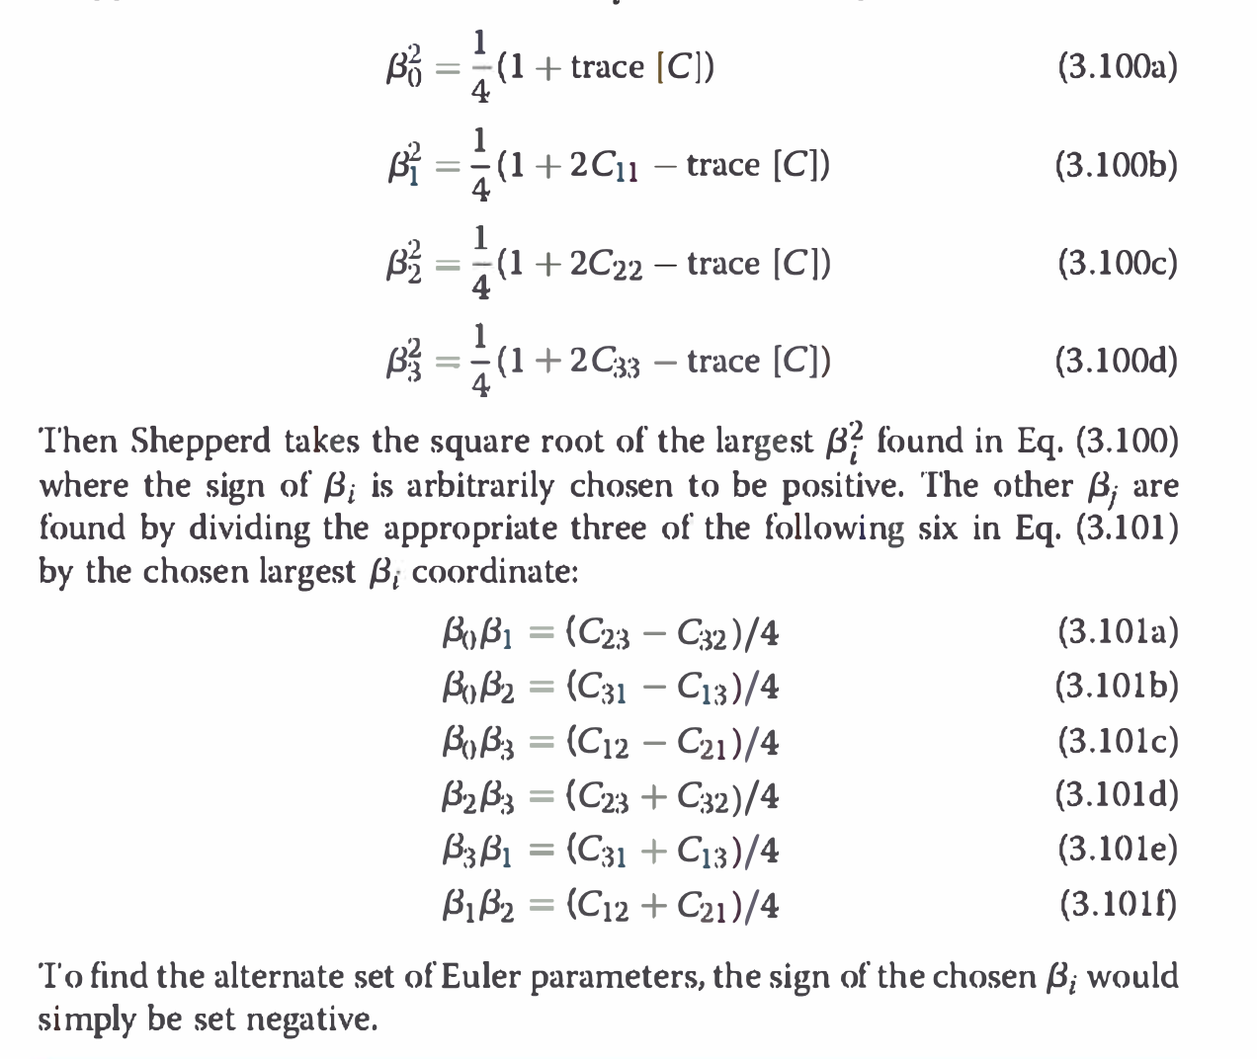
A very important composite rotation property of the Euler parameters
is the manner in which they allow two sequential rotations to be combined
into one overall composite rotation.
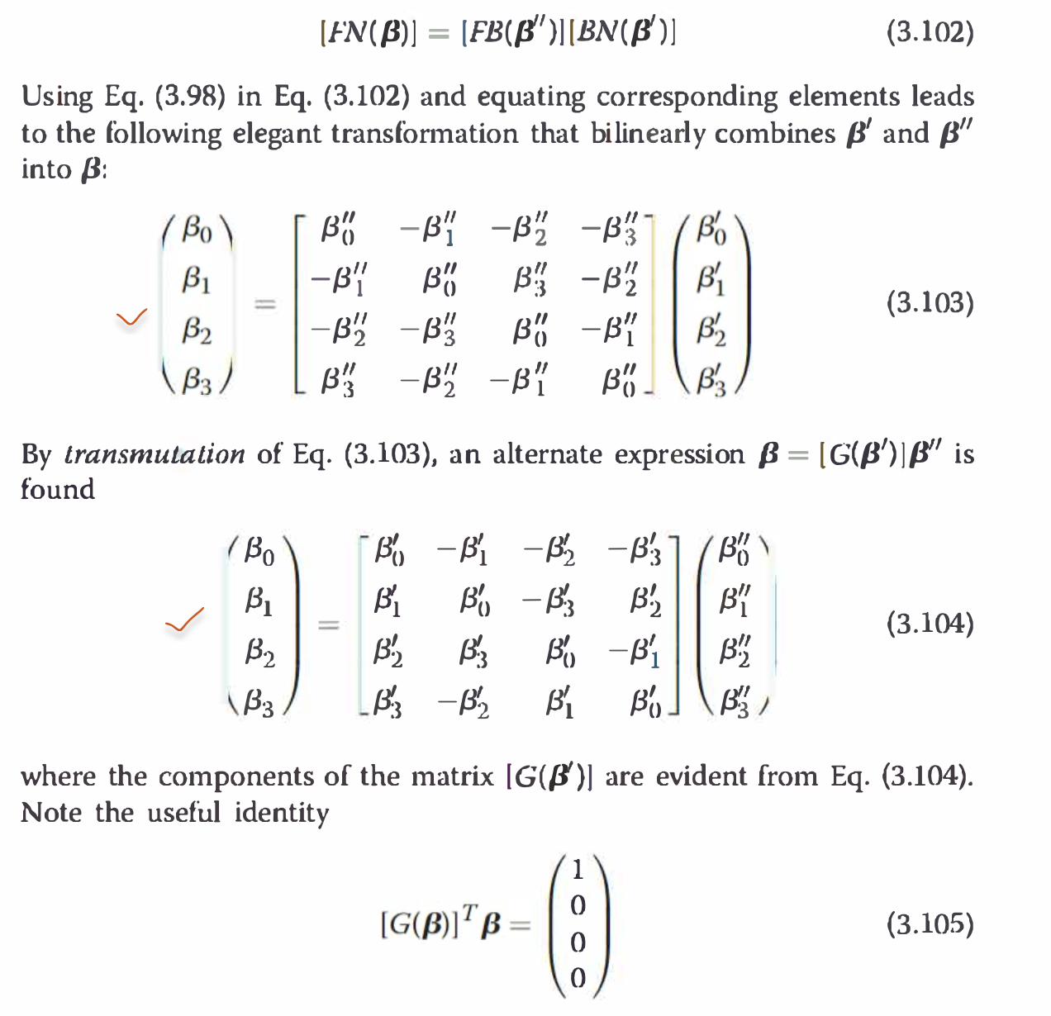
t is evident that the 4 x 4 matrices in Eqs. (3.103) and
(3.104) are orthogonal. These transformations provide a simple, nonsingular,
and bilinear method to combine two successive rotations described
through Euler parameters. For other attitude parameters such as the
Euler angles, this same composite transformation would yield a very complicated,
transcendental expression.
The kinematic differential equation for the Euler parameters can be
derived by differentiating the {3i in Eq. (3.99). The following development
. .
will establish the l<inematic equation for {30 only; the remaining {3i equations
can be developed in an analogous manner.
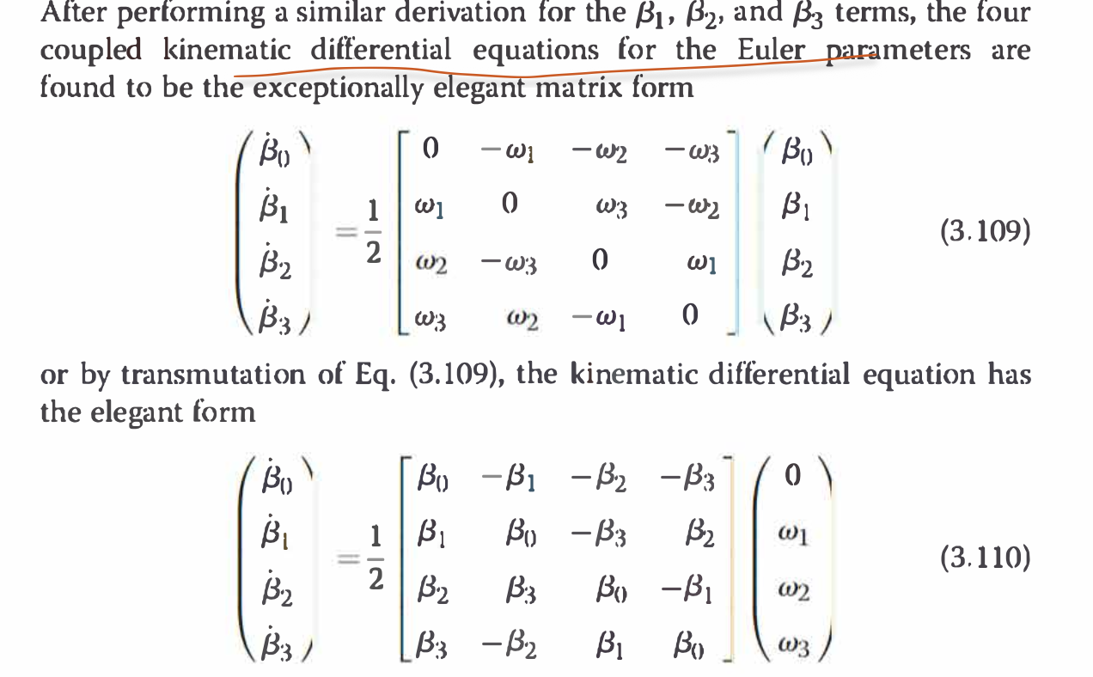

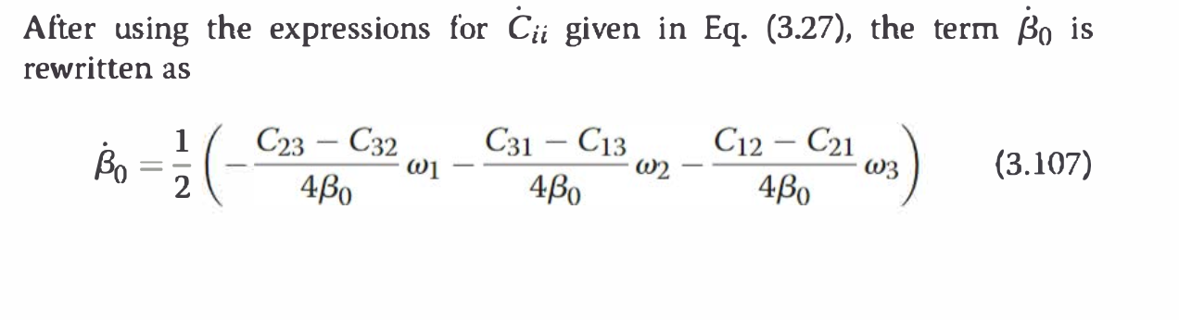
he inverse transformation from w to d(/3) / dt is always
defined. Further, the Euler parameter kinematic differential equation of
Eq. (3.109) is rigorously linear if wi(l) are l<nown functions of time only. If
wi(t) are themselves coordinates, then Eqs. (3.109) and (3.110) are more generally
considered bilinear.

T'his mal<es the Euler parameters very attractive
attitude coordinates for attitude estimation problems where the l<inematic
differential equation is linearized. All three parameter sets of attitude coordinates
always have l<inematic differential equations that are nonlinear and
contain 0/0 type mathematical singularities. In attitude estimation problems
their linearization is only locally valid, whereas the linear (or bilinear) property
of the Euler parameter kinematic diff
erential equation is globally valid.
The Euler parameter l<inematic differential equation in Eq. (3.110) can be
written compactly as
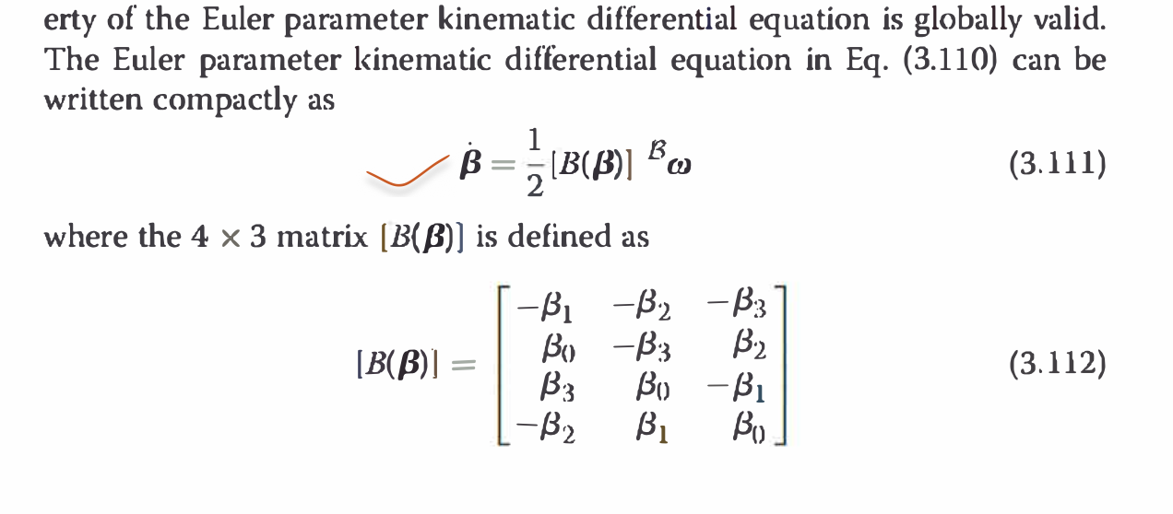

e normalization condition pT p = 1 is a rigorous
analytical integral of Eqs. (3.109) and (3.110). However, in practice the norm
of P may slightly differ from 1 when numerically integrating Eq. (3.109). It
is therefore necessary to tal<e care to reimpose this condition differentially
after each numerical integration step, if the solution is to remain valid over
long time intervals. However, in contrast to the renormalization of [C(t)]
to satisfy [C] T[C] = [l3x3] when solving Eq. (3.27), only one scalar condition
needs to be considered when integrating P(t).
In control applications, often the four Euler parameters are broken up
into two groups. The parameter {30 is singled out because it contains no
information regarding the corresponding principal rotation axis of the
orientation being represented. In effect, it is a scalar measure of the threedimensional
rigid body attitude measure whose value is + 1 or -1 if the attitude
or angular displacement is zero. The remaining three Euler parameters
are grouped together into a three-dimensional vector as
